Using JBuilder's CORBA tools
This chapter explains the CORBA (Common Object Request Broker Architecture) tools available in JBuilder, including the VisiBroker ORB and IDL compilers.
The Common Object Request Broker Architecture (CORBA) allows distributed applications to interoperate (application to application communication), regardless of what language they are written in or where these applications reside.
The CORBA specification was adopted by the Object Management Group to address the complexity and high cost of developing distributed object applications. CORBA uses an object-oriented approach for creating software components that can be reused and shared between applications. Each object encapsulates the details of its inner workings and presents a well defined interface, which reduces application complexity. The cost of developing applications is reduced, because once an object is implemented and tested, it can be used over and over again.
The Object Request Broker (ORB) connects a client application with the objects it wants to use. The client program does not need to know whether the object implementation it is in communication with resides on the same computer or is located on a remote computer somewhere on the network. The client program only needs to know the object's name and understand how to use the object's interface. The ORB takes care of the details of locating the object, routing the request, and returning the result.
Note: The ORB itself is not a separate process. It is a collection of libraries and network resources that integrates within end-user applications, and allows your client applications to locate and use objects.
JBuilder supports the VisiBroker ORB and the OrbixWeb ORB. JBuilder also provides tools to configure other third-party ORBs.

How JBuilder and the VisiBroker ORB work together
The VisiBroker ORB provides a complete CORBA ORB runtime and supporting development environment for building, deploying, and managing distributed Java applications that are open, flexible, and inter-operable. The VisiBroker ORB is part of the Borland Enterprise Server. Objects built with the VisiBroker ORB are easily accessed by Web-based applications that communicate using OMG's Internet Inter-ORB Protocol (IIOP) standard for communication between distributed objects through the Internet or through local intranets. The VisiBroker ORB has a native implementation of IIOP to ensure high-performance and inter-operability.
The VisiBroker ORB incorporates the following compilers for working in a Java environment:
- java2iiop
The java2iiop compiler allows you to stay in an all-Java environment. The java2iiop compiler takes your Java interfaces and generates IIOP-compliant stubs and skeletons. Part of the advantage of using the java2iiop compiler is that, through the use of extensible structs, you can pass Java serialized objects by value.
- java2idl
The java2idl compiler turns your Java code into IDL, allowing you to generate client stubs in the programming language of your choice. In addition, because this compiler maps your Java interfaces to IDL, you can re-implement Java objects in another programming language that supports the same IDL.
When you develop distributed applications with JBuilder and the VisiBroker ORB, you must first identify the objects required by the application. You will then usually follow these steps:
- Write a specification for each object using the IDL wizard to generate the Interface Definition Language (IDL) file. IDL is the language an implementer uses to specify the operations an object will provide and how they should be invoked.
- Use the IDL compiler to generate the client stub code and server Portable Object Adapter (POA) servant code.
- Write the client program code.
- Write the server object code.
- Compile the client and server code.
- Start the server.
- Run the client program.
For in-depth information on using the VisiBroker ORB to create distributed applications, see the VisiBroker documentation in the doc directory of your Borland Enterprise Server installation.
The tutorial "Creating a CORBA application" will help you become familiar with the JBuilder and VisiBroker ORB development tools.
For more information about Common Object Request Broker Architecture (CORBA), some useful links are:
- http://www.borland.com/books - Books on Borland products and related technologies
- "A White Paper: Java, RMI, and CORBA" at http://www.omg.org/news/whitepapers/wpjava.htm
- CORBA/IIOP Specification at Introduction to OMG's Specifications
- CORBA Basics at http://www.omg.org/gettingstarted/corbafaq.htm

RMI
Another way to invoke methods on remote Java objects is to use Remote Method Invocation (RMI). The Borland Enterprise Server provides capabilities equivalent to RMI, but, in addition, allows you to create Java objects that communicate with all other objects that are CORBA compliant even if they are not written in Java. For an example of a Java interface that describes an RMI remote interface, see the sample file Account.java in the examples/vbe/rmi-iiop/Bank directory of your Borland Enterprise Server installation.

Setting up JBuilder for CORBA applications
This section explains how to set up JBuilder with the VisiBroker ORB or OrbixWeb so that you can create, run, and deploy CORBA applications. You can also configure other, third-party ORBs. More information on the VisiBroker ORB is available in the doc directory of your Borland Enterprise Server installation. Consult the OrbixWeb documentation for information on particular features of that ORB.

Configuring VisiBroker when the Borland Enterprise Server is installed
Follow the steps in this section to set up JBuilder for use with VisiBroker when the Borland Enterprise Server AppServer Edition 5.2.1 is already installed, configured and the target server for your project. Note that the server creates its own VisiBroker configuration. For information on configuring Borland Enterprise Server, see "Using JBuilder with Borland servers."
- Choose Tools|Enterprise Setup to display the Enterprise Setup dialog box. Select the CORBA node. The parameters in this dialog box allow JBuilder to see the ORB.
- Select the VisiBroker (Borland Enterprise Server AppServer Edition 5.2.1) option from the Configuration drop-down list. The Enterprise Setup dialog box will look similar to this:
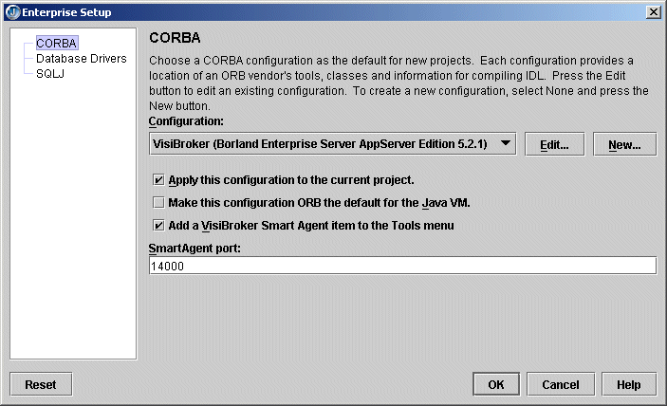
- Click OK to close the dialog box. You do not have to complete other configuration steps; JBuilder is now configured for use with VisiBroker.
- Click OK to save the configuration.
You've now completed setting up your system to use the VisiBroker version installed with the Borland Enterprise Server AppServer Edition 5.2.1. Before running your application, choose Tools|VisiBroker Smart Agent to start the Smart Agent. (Note that it is also automatically started when you start the Management Agent with the Tools|Borland Enterprise Server Management Agent command.) For a tutorial that uses these features to create a CORBA application, see "Creating a CORBA tutorial in JBuilder."

Configuring VisiBroker stand-alone
Follow the steps in this section to set up JBuilder for use with VisiBroker stand-alone; that is, without targeting your project for the Borland Enterprise Server AppServer Edition 5.2.1.
- Choose Tools|Enterprise Setup to display the Enterprise Setup dialog box. Select the CORBA node. The parameters in this dialog box allow JBuilder to see the ORB.
- Select the VisiBroker option from the Configuration drop-down list. The Enterprise Setup dialog box will look similar to this:
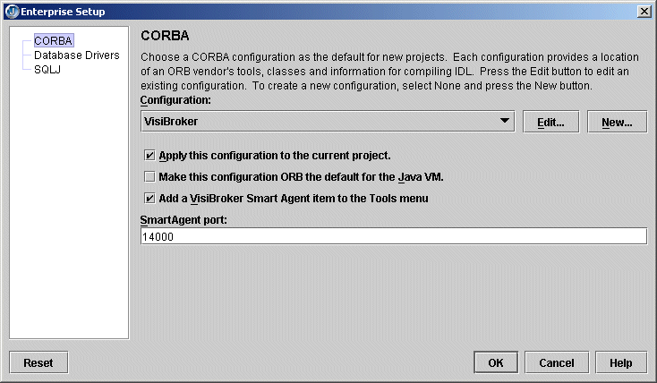
- Click the Edit button to display the Edit Configuration dialog box. The Edit Configuration dialog box looks like this:
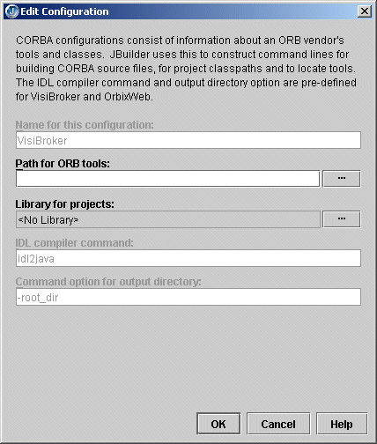
- The Path For ORB Tools field allows JBuilder to access ORB tools. Click the ellipsis (…) button next to the Path For ORB Tools field to browse to the directory containing the ORB tools. Point to the directory that contains the osagent.exe file. This is the bin directory of your Borland Enterprise Server installation.
- The Library For Projects field defines the library location of the ORB tools To define the library location, click the ellipsis (…) button next to the Library For Projects field. This displays the Select A Different Library dialog box, that will look similar to this:
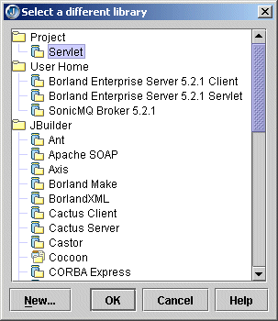
The library is necessary for compiling the generated stubs and skeletons and for executing an application. For VisiBroker, browse to the Borland Enterprise Server 5.2.1 Client library, then click OK two times.
- In the Enterprise Setup dialog box, leave the Apply This Configuration To The Current Project option selected in order to set this ORB configuration for the current project, as well as the default project.
- Set the Make This Configuration's ORB The Default For The Java VM option to use the selected ORB as the default ORB for the Java VM.
- Select the Add A VisiBroker Smart Agent Item To The Tools Menu option to enable the Smart Agent to run as a JBuilder service during development. This option will be disabled if the Smart Agent is not necessary.
- Select a port on which to run the Smart Agent. The default port of 14000 will work on most systems.
Note: When running the project, you can use a JBuilder macro in the VM Parameters field on the Edit Runtime Configuration dialog box for the application. This macro allows the project to be used on another machine where the Smart Agent is configured for a different port. The syntax is:

-Dvbroker.agent.port=($SmartAgentPort)
- Click OK to save the configuration.
You also need to pass options to the IDL compiler. To do this,
- Choose Project|Project Properties|Build|IDL to display the IDL Build page, which will look similar to this:
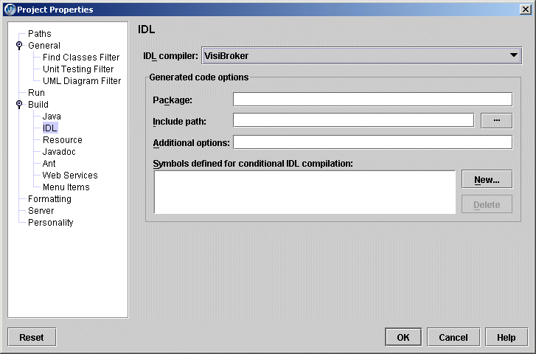
- Make sure VisiBroker is selected as your IDL compiler.
- Enter the following options into the Additional Options field:

- -VBJprop borland enterprise.licenseDir=<visibroker license directory>
- -VBJjavavm<jdk1.4.1 java or javaw path>
The license directory is APPSERVER_HOME\var\servers\SERVER_NAME\adm. The <server directory> is same as the server name assigned when you configured the server using Tools|Configure Servers. You can find the server name on the Custom page of the Configure Servers dialog box.
- Click OK to close the Project Properties dialog box.
You must still perform one step: starting the VisiBroker Smart Agent. This handles the initial bootstrap issues such as how the client locates the naming service and so on. To start the Smart Agent, choose Tools|VisiBroker Smart Agent.
You've now completed setting up your system to use the JBuilder CORBA features. For a tutorial that uses these features to create a CORBA application, see "Creating a CORBA application."

Configuring the OrbixWeb ORB
Follow the steps in this section to set up JBuilder for use with the OrbixWeb ORB.
- Choose Tools|Enterprise Setup to display the Enterprise Setup dialog box. Select the CORBA page. The parameters in this dialog box allow JBuilder to see the ORB.
- Select the OrbixWeb option from the Configuration drop-down list. The Enterprise Setup dialog box will look similar to this:
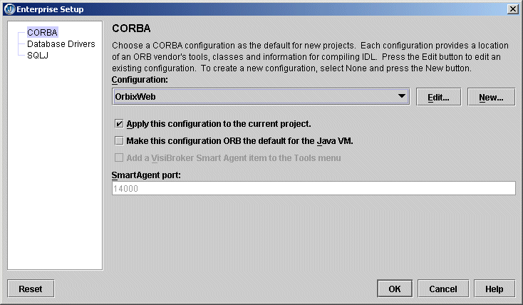
- Click the Edit button to display the Edit Configuration dialog box. The Edit Configuration dialog box will look similar to this:
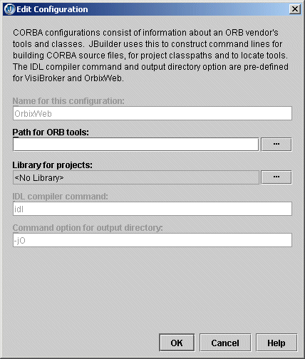
- The Path For ORB Tools field allows JBuilder to access ORB tools. Click the ellipsis (…) button next to the Path For ORB Tools field to browse to the directory containing the ORB tools.
- The Library For Projects field defines the library location of the ORB tools. To define the library location, click the ellipsis (…) button next to the Library For Projects field. This displays the Select A Different Library dialog box. The library is necessary for compiling the generated stubs and skeletons and for executing an application. Choose the library and click OK two times.
- In the Enterprise Setup dialog box, leave the Apply This Configuration To The Current Project option selected if this ORB configuration should be applied to the current project as well as the default project.
- Set the Make This Configuration's ORB The Default For The Java VM option to use the selected ORB as the default ORB for the Java VM.
- Click OK to save the configuration.

Adding a new configuration
Follow the steps in this section to create a new configuration for a third-party ORB.
- Choose Tools|Enterprise Setup to display the Enterprise Setup dialog box. Select the CORBA page. The parameters in this dialog box allow JBuilder to see the ORB.
- Select the None option from the Configuration drop-down list, then click the New button. The New Configuration dialog box is displayed.
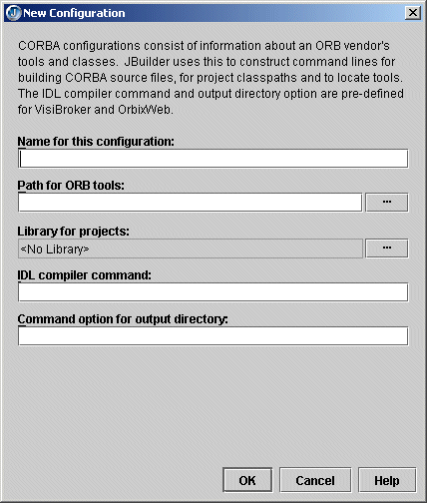
- Enter a name for the configuration in the Name For This Configuration field.
- Enter the path for the ORB tools in the Path For ORB Tools field. Click the ellipsis (…) button to browse to the directory containing the ORB tools.
- Click the ellipsis (…) button next to the Library For Projects field to display the Select A Different Library dialog box. You use this dialog box to browse to the library location of the ORB tools. The library is necessary for compiling the generated stubs and skeletons and for executing an application. The Select A Different Library dialog box looks like this:
  - To add a library that is not displayed in the Select A Different Library dialog box, click the New button.
  - In the New Library wizard, enter a name for the new library in the Name field.
  - Select a location for the library: the JBuilder directory, the project directory, or your home directory.
  - Click Add to browse to the library (JAR) file.
  - Click OK until you return to the New Configuration dialog.
- Enter the command for the IDL compiler in the IDL Compiler Command field.
- Enter the IDL compiler command option that specifies the output directory in the Command Option For Output Directory field.
- Click OK to close the New Configuration dialog box.
- In the Enterprise Setup dialog box, leave the Apply This Configuration To The Current Project option selected in order to set this ORB configuration for the current project, as well as the default project.
- Click OK to save the new configuration.

Setting and viewing ORB build properties
This section explains how to set and view build properties for the installed ORB.

Setting VisiBroker ORB properties
To set and view properties for the java2iiop and java2idl compilers in the JBuilder development environment,
- Choose Project|Project Properties|Build|IDL. The IDL page is displayed.
Make sure the IDL Compiler field is set to VisiBroker or VisiBroker (Borland Enterprise Server AppServer Edition 5.2.1).
- Set the Generated Code Options as needed:
  - In the Package field, enter the name of the package to generate code in. The package name for definitions is prepended with the specified package name. If a directory with the specified package name does not exist, it will be created. If the package directory exists, its contents will be updated. code is generated that uses CORBA package resolution rules.
  - In the Include Path field, enter the location where other files that are referenced from IDL files reside. Click the ellipsis (…) button beside this field to open a dialog box that lets you browse the directory structure for the location of the files.
  - In the Additional Options field, enter any additional options for your IDL compiler, as you would enter them when running the compiler from the command line.
  - The Symbols Defined For Conditional IDL Compilation list displays symbols that have been defined for conditional IDL compilation. Click the New button to display the Define New Symbol dialog box where you can define a new conditional symbol. To remove a symbol from the list, select it then choose the Delete button.
- Choose the Paths node of the Project Properties dialog box. Make sure the Required Libraries list includes the Borland Enterprise Server 5.2.1 Client.
- Click OK to close the Project Properties dialog box.
- Once you've created a Java interface file in your JBuilder project, right-click the file in the project pane and choose Properties.
- On the Build|VisiBroker node, select the Generate IDL and Generate IIOP options. The dialog box should look like this:
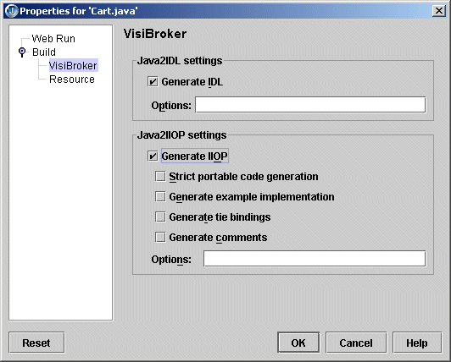
  - Select the Java2IDL Generate IDL option to generate an Interface Definition Language (IDL) file from a Java file or a class file. To support the distribution of objects implemented in a variety of programming languages, an IDL file is used to define the services offered by a particular distributed object.
  - Enter any Java2IDL command line options in the Options field. See the Borland Enterprise Server VisiBroker documentation for command line options.
  - The Java2IIOP Generate IIOP Interface option generates an Internet InterORB (Object Request Broker) Protocol (IIOP) compatible Java interface file from a Java interface or class file. This is done by creating a new Java interface that extends org.omg.Corba.object. This Java interface can be used to describe CORBA interfaces in place of using an Interface Definition Language (IDL) file to describe the interfaces. The IIOP protocol maintains a basic set of functionality to ensure inter-operability between client applications and server-based objects in a Common Object Request Broker Architecture (CORBA) architecture.
  - Set the Java2IIOP Strict Portable Code Generation (Java2IIOP) option to enable generation of portable stubs, that is, stubs that contain code not specific to VisiBroker.
  - Set the Java2IIOP Generate Example Implementation option to enable generation of example implementation code.
  - Set the Java2IIOP Generate Tie Bindings option to enable generation of tie classes.
  - Set the Java2IIOP Generate Comments option to enable generation of comments in the source code.
  - Enter any Java2IIOP command line options in the Options field. See the Borland Enterprise Server VisiBroker documentation for command line options.
- Click OK to close the dialog box.

Setting build properties for the OrbixWeb or other third-party ORBs
To set and view properties for configured ORB,
- Choose Project|Project Properties|Build|IDL. The IDL page is displayed.
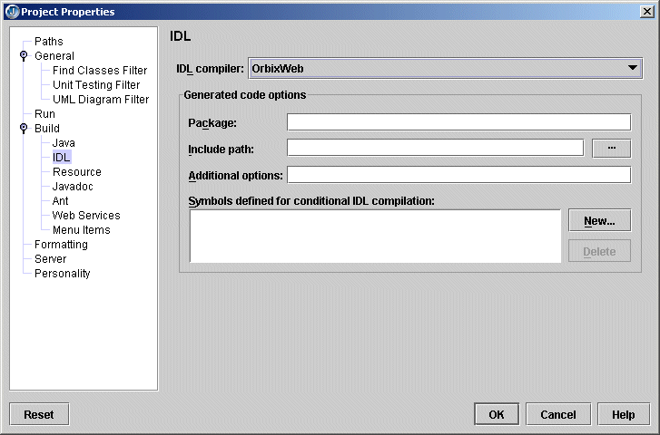
Make sure the IDL Compiler field matches the ORB you selected in the Enterprise Setup dialog box.
- Set the Generated Code Options as needed:
  - In the Package field, enter the name of the package to generate code in. The package name for definitions is prepended with the specified package name. If a directory with the specified package name does not exist, it will be created. If the package directory exists, its contents will be updated. code is generated that uses CORBA package resolution rules.
  - In the Include Path field, enter the location where other files that are referenced from IDL files reside. Click the ellipsis (…) button beside this field to open a dialog box that lets you browse the directory structure for the location of the files.
  - In the Additional Options field, enter any additional options for your IDL compiler, as you would enter them when running the compiler from the command line.
  - The Symbols Defined For Conditional IDL Compilation list, displays symbols that have been defined for conditional IDL compilation. Click the New button to display the Define New Symbol dialog box where you can define a new conditional symbol. To remove a symbol from the list, select it then choose the Delete button.
- Choose the Paths node in the Project Properties dialog box. Make sure the Required Libraries list includes the libraries specific to the ORB you're working with.
- Click OK to close the Project Properties dialog box.

Setting and viewing IDL build properties
This section explains how to set and view build properties for an IDL file. You must first create an IDL file. You can use the Sample IDL wizard, available on the Enterprise|CORBA node of the object gallery.
- Right-click an IDL file in the project pane and choose Properties. The Compiler Options page of the Build node (Properties dialog box) is displayed:
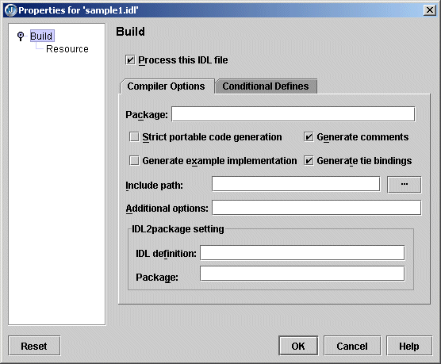
  - Set the Process This IDL File option to set compiler options, add the compiled files and/or packages to the current project, and view compiler output.
  - Enter the package for generated code in the Package field. The package name for definitions is prepended with the specified package name. If a directory with the specified package name does not exist, it will be created. If the package directory exists, its contents will be updated. When this option is not set, idl2java generates code using the CORBA package resolution rules..
  - Select the Strict Portable Code Generation option to generated code code that can run on any CORBA-compliant ORB. This means that any VisiBroker-specific code will not be generated, including code that generates smart stubs. Selecting this option also suppresses the generation of toString() and bind() methods. When this option is selected, the compiler generates skeleton code using the Dynamic Skeleton Interface (DSI).
If not selected, the portable stubs will not be generated. VisiBroker-specific extensions and optimizations will be present in the code that is generated. Generated stubs will specifically be for use in VisiBroker ORB environments.
  - Select the Generate Example Implementation option to generate example classes when the IDL file is compiled. If not selected, the generation of example classes will be suppressed.
  - Select the Generate Comments option to generate comments in the code. If not selected, comments will be suppressed in the generated code.
  - Select the Generate Tie Bindings option to generate _tie classes when the IDL file is compiled. If this option is not selected, the generation of _tie classes will be suppressed.
The tie mechanism offers an alternative when it is not convenient or possible to have your implementation class inherit from the VisiBroker skeleton class. Object implementation classes must inherit from the VisiBroker skeleton class. Java does not allow multiple class inheritance and you may want your implementation class to inherit from a different class.
Inheritance is easier to use than the tie mechanism because implementation objects look and behave just like object references. If an implementation object happens to be in the same process as a client using it, operation invocations involve less overhead because no transport, indirection, or delegation of any kind is required.
The tie mechanism provides a delegator implementation class that inherits from org.omg.CORBA.Object. The delegator implementation class does not provide any semantics of its own. It simply delegates every call to the real implementation class, which can be implemented separately and can inherit from whichever class it wishes.
The Operations class defines all of the methods that must be implemented by the object implementation. This class acts as the delegate object for the associated _tie class when the tie mechanism is used.
  - Click the ellipsis (…) button next to the Include Path field to display the Select Directory dialog box, where you can select a directory to search for the list of files to include in the build. You must select a directory that contains an .idl file.
  - Enter options not available in this dialog box in the Additional Options field.
  - The IDL2package Setting options are the equivalent of the command line parameter -idl2package idl pkg. If any part of the IDL file is in the scope ::CORBA,the generated is code is placed in the org.omg.CORBA package. When this option is not set, the generated code uses the CORBA package resolution rules.
    - IDL Definition - The definition in scope of IDL.
    - Package - The Java package into which to place the IDL definition.

- Click the Conditional Defines tab to set symbols defined for conditional compilation.
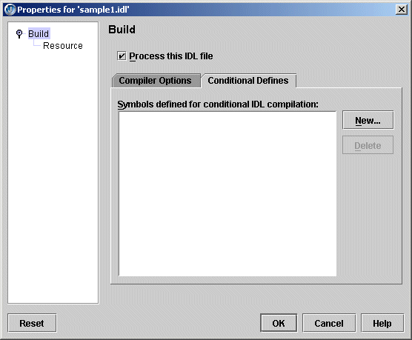
  - The Symbols Defined for Conditional IDL Compilation list displays a list of symbols defined for conditional IDL compilation.
  - Click the New button to display Define New Symbol dialog box, where you to define a symbol name for conditional IDL compilation, for example #define name def.
  - Choose a symbol and click the Delete button to delete the selected symbol from the list of symbols defined for conditional compilation.
- Click the OK button to set the options to be used by the VisiBroker idl2java compiler, when the IDL file is compiled. Set the correct options so that when compiled, Java interface definitions and Java client and server stubs and skeletons are generated in a subdirectory of the project with the same name as the project.
When the Process This IDL File option is not checked, selecting OK saves the selected options, but does not call the idl2java compiler when the IDL file is compiled. This means that the client stubs and server skeletons are not generated when the IDL file is compiled.

Using the CORBA wizards
This section describes the JBuilder wizards that are available for CORBA development. Wizards provide quick and easy development of IDL files and CORBA client and server interfaces. These wizards are available only if your project is configured for use with CORBA (Tools|Enterprise Setup|CORBA).

Sample IDL wizard
The Sample IDL wizard creates a simple IDL file that may be used to experiment with the various CORBA tools that take an IDL file as input. The generated IDL file will consist of a module and an interface containing a single method that can be customized. This wizard is available on the Enterprise|CORBA node of the object gallery.
The Sample IDL wizard looks like this:
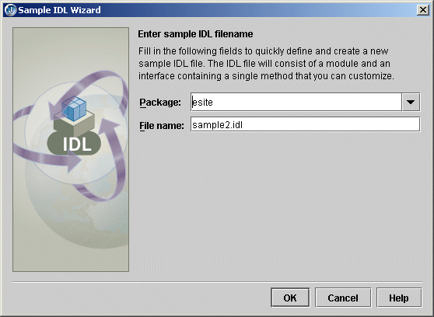

CORBA Client Interface wizard
The CORBA Client Interface wizard produces a layer over idl2java-generated code allowing a client application to easily invoke the interface methods of a running CORBA server. You will be able to invoke methods in the interface that will be executed on a CORBA server when you are connected to an Object Request Broker (ORB). This wizard is only available if you have an IDL file in your project. It is available on the Enterprise|CORBA node of the object gallery.
The CORBA Client Interface wizard looks like this:
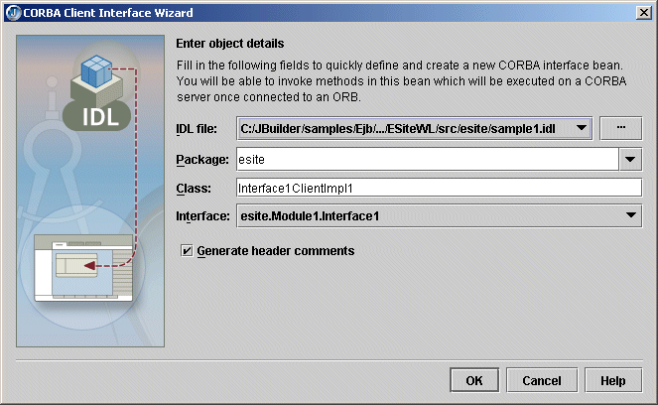

CORBA Server Interface wizard
The CORBA Server Interface wizard lets you define and create a new Java CORBA server interface bean. Complete the method stubs and add the bean to an application to create a working CORBA server for that interface. This wizard is only available if you have an IDL file in your project. It is available on the Enterprise|CORBA node of the object gallery.
The CORBA Server Interface wizard looks like this:
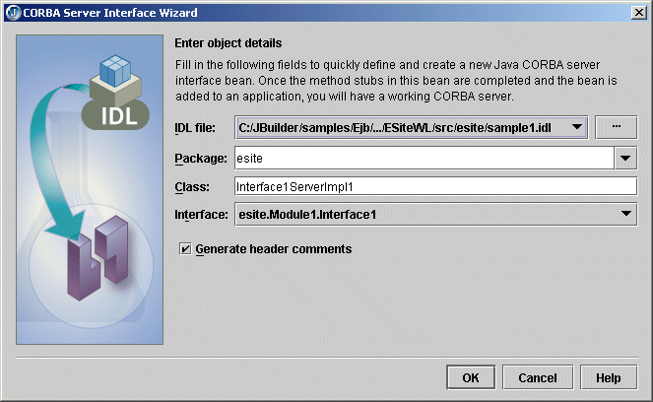

HTML CORBA Client wizard
The HTML CORBA Client wizard produces a JSP or HTML client application that provides input to a CORBA server. This wizard is only available if you have an IDL file in your project and a web server is selected. It is available on the Enterprise|CORBA node of the object gallery.
The Enter Application Details page of the HTML CORBA Client wizard looks like this:
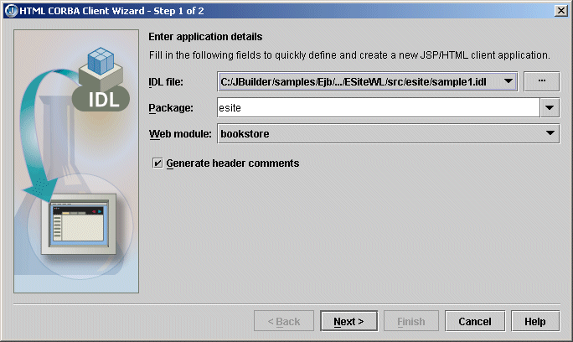
The final page of the wizard is where you create a runtime configuration.

CORBA Server Application wizard
The CORBA Server Application wizard produces an application that provides a complete default implementation for a CORBA server. This wizard is only available if you have an IDL file in your project. It is available on the Enterprise|CORBA node of the object gallery
The Enter Application Details page of the CORBA Server Application wizard looks like this:
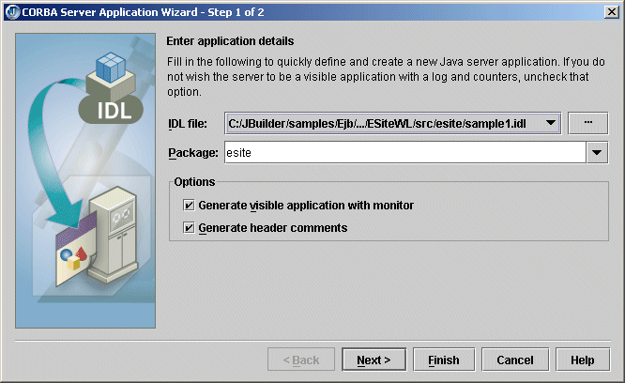
The final page of the wizard is where you create a runtime configuration.

Use CORBA Interface wizard
This Use CORBA Interface wizard creates a client CORBA application. It will create a reference to a CORBA client interface that was built earlier, or it will create one. This wizard is only available if you have an IDL file in your project and a .java file open in the editor. It is available from the Wizards menu.
The first page of the Use CORBA Interface wizard, where you choose whether to use an existing client interface, looks like this:
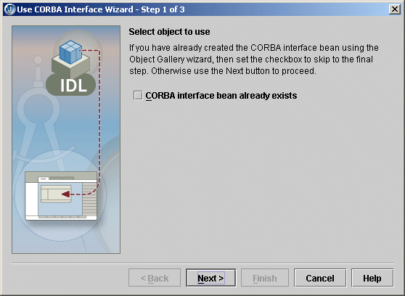
The second page of the wizard, where you define and create the new CORBA interface bean looks like this:
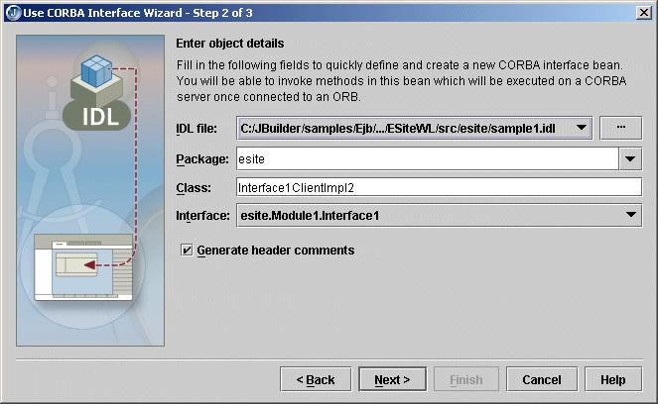
The final page of the wizard is where you create a runtime configuration.

